**Pedestrian Navigator**

General:

This software calculates the shortest route between the buildings in the Technion for the given road network.

The software interface is based on loading two text files in ".txt" format only. One contains a series of coordinates for each polygon, where each polygon represents a building within the Technion, and the other contains a series of coordinates for each route, where a route represents a route between two polygons.  
The user loads the files while the program is running and the software creates appropriate objects from them on the map.

After marking a source building and a destination building by the user and when the user clicks on the Find Shortest Path button, the software creates a graph and with the "Dijkstra" algorithm, the software calculates the fastest route between the two buildings.

At the end of the operations (when they are performed correctly by the user), the shortest route will be displayed on the map in yellow.

**The purpose of the software:** saving time and unnecessary effort to navigate the Technion campus.

The user manual is detailed on the following pages.

User guide:

1. **Map** screen - from the moment the program is run, a window will open with a map of the Technion. At the top of the window is the "Tools menu".

87dcd32e78c94b1ffe40bbe5fe895476.png

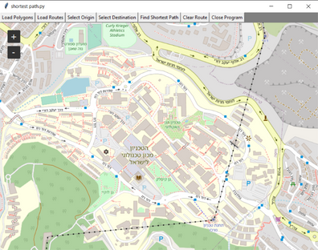

1. **Loading data files to the map - to upload the data file of the buildings and display them on the map, click on the "Load Polygons" button located in the "Tools menu".**

After the operation, the buildings will be colored yellow on the map, with red outlines.

Similarly, click on the "Load Routes" button in the "Tools menu".

After the operation, the map will be colored with a black road network.



The map and the representation of the buildings on it, after pressing the "+" key, which zooms in on the display. 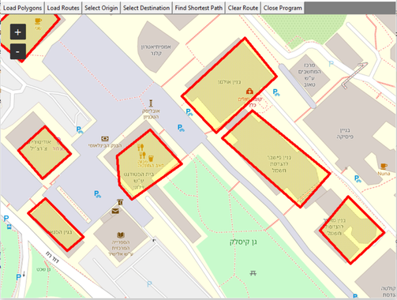

After loading the buildings and the road network, we will want to select starting and destination points:

**Selecting an origin - to select an origin point, click on the "Select Origin" button in the "Tools menu". After clicking the button, select the desired origin point by clicking the right-click button and inside the yellow-red polygon. The polygon will only be selected if the click was made when the pointer was inside the boundaries of the polygon.** After performing the operation, the polygon will be colored light blue.



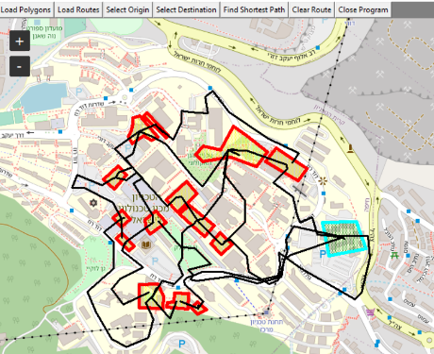

1. **Selecting a destination - to select a destination point, click the "Select Destination" button in the "Tools menu". After clicking the button, select the desired destination point by clicking the right mouse button and inside the yellow-red polygon. The polygon will select only If the click was made with the mouse cursor inside the polygon boundaries.**

After performing the operation, the polygon will be colored light blue.

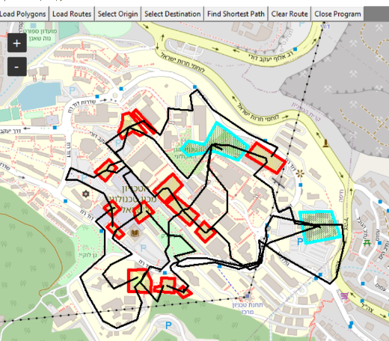

1. **Calculating the shortest distance - press a button**

"Find Shortest Path" in the "Tools menu".

After clicking, the system will calculate the shortest route and display it in yellow on the map. In addition, the origin and destination buildings and all the buildings that the route passes through will be colored orange. The software will provide: a list of the buildings on the shortest route, where the number of the leftmost building is the origin and the rightmost is the destination.



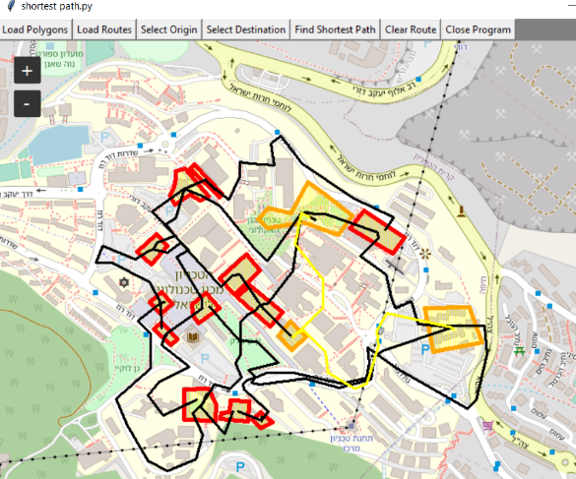

1. **Removing the data and calculating a new route - in order to perform another calculation on the same road network, you must use the "Clear Route" button, which, by clicking on it, will delete the route and the start and end points from the map. Now, it will be possible to repeat steps 3, 4 and 5 again.**

968fe7d89130082bcc9679fd53018d95.png

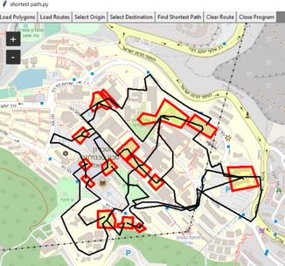

1. **Exiting the software - to exit the software, click on the "Close Program" button found in the "Tools menu".**

97dfcdf91714cac5963f6b6b7d25658d.png

